Authors’ guidelines for ASFE DUBROVNIK 2015 proceedings
Template for the Preparation of Manuscripts using Microsoft Word
Tomaz Hozjanª, Robert Ofner^{b}
ª University of Ljubljana, Faculty of Civil and Geodetic Engineering, Ljubljana, Slovenia
^{b} Graz University of Technology, Institute for Steel Structures and Shell Structures, Graz, Austria
Abstract
The abstract must be 10 lines maximum. It should present a concise statement of the scope, work, principal findings, and conclusions of the paper.

Keywords: keyword 1, keyword 2, ...., 5 keywords maximum (Times New Roman font, 12pt)

1 Introduction
This template has been prepared in the format to be used for papers to be published in the Proceedings of the 4th International Conference on Applications of Structural Fire Engineering.
The paper must be written in English. The length of the paper, including figures, tables, and references, should be 6 pages of size A4. Please do not insert page numbers and do not lock the PDF file because the conference office has to insert the page numbers.
The paper starts with Abstract, Keywords and Introduction and finishes with Conclusions, Acknowledgements and References.
The title of the paper should be fully descriptive. A long title should be split into a single-line title and a subtitle. The title should be centre-aligned, in 14pt Times New Roman font, bold capitals, and sub-title should be centre-aligned, in 12pt Times New Roman font, bold initial capitals.
Each author’s name should include first name, middle name initials and last name. The “authors” line should be written centre aligned, in 12pt lowercase Times New Roman font, 12pt below the title or sub-title respectively.
Authors’ affiliation(s) should each be centre aligned, in 10pt using initial capitals Times New Roman font, 12pt below the list of authors. There is single-spacing between different affiliations.
The Abstract should be in 12pt Times New Roman font. The word Abstract should be in Times New Roman font, boldface, while abstract text should be justified and separated 1 space blank line with 12pt from the keywords.

2 HEADING 1
Major headings are to be typed in bold capitals Times New Roman font, 12pt. Do not use automatic numbering; after the section number use a Tab stop at 8 mm. The line spacing before a heading should be 12pt, and after a heading 6pt.
The normal text should be single-spaced and justified, using Times New Roman font, 12pt in a single column. There should be no inter-paragraph spacing.

2.1 Heading 2
Secondary headings are to be typed in bold, using initial capitals. Please limit the extent of sub-headings to major and secondary headings. As for HEADING 1, please do not use automatic numbering; after the section number use a Tab stop at 8 mm. The line spacing before a secondary heading is also 12pt, with 6pt after the heading.

3 Preset formatS
All settings are already adjusted in the Word Styles listed below. Use these Formats to give a consistent layout to the conference proceedings.
- Title of paper
- Sub-title
- Authors
- Affiliation
- Abstract
- Heading 1
- Heading 2
- Normal
- Bulleted list
- Numbered list
- Table caption
- Figure caption
- References

3.1 Margins, Tables and Equations
Please use page size A4. Information on margins is provided in Table 1. All text, figures, and tables must fit within the prescribed margins.
All tables should be numbered consecutively and captioned; the caption and the body text within the table should be centred, written with 11pt Times New Roman font, upper and lower case letters.
Table 1 Margins of the page size A4 [mm]
top | bottom | inside | outside
20 | 15 | 25 | 15
The distance between the text and a table caption must be 12 pt. A 6pt space should separate the table from the caption, and a 12pt space should separate the table from the text below the table.
The equations must be centred and a distance of 6 pt should separate them from the surrounding text. For equations, the standard settings of the Word equation editor should be used. The equations must be numbered consecutively using Arabic characters included in parenthesis and right aligned. An example is given in Eq. (1).
(1)
where A, e capital and small font Times New Roman 12pt, italic,
Ω, α capital and small font Symbol.
MKS SI units should be used throughout the text, figures and tables. If other units are used, then metric equivalents should be given in parentheses.

3.2 Figures and Photographs
All illustrations should be placed near to their first mention in the text. Figures should have a resolution of 600 dpi. Colour printing will not be provided in the Proceedings. When preparing figures, please bear in mind that the proceedings will be printed in B5 format (78% of the original A4 size). The smallest font size in figures should not be smaller than 10pt. If the manuscript includes a photograph, figure or extract which has previously been published, the author must obtain written approval from the original publisher for it to be reprinted, and provide the corresponding reference and acknowledgment.

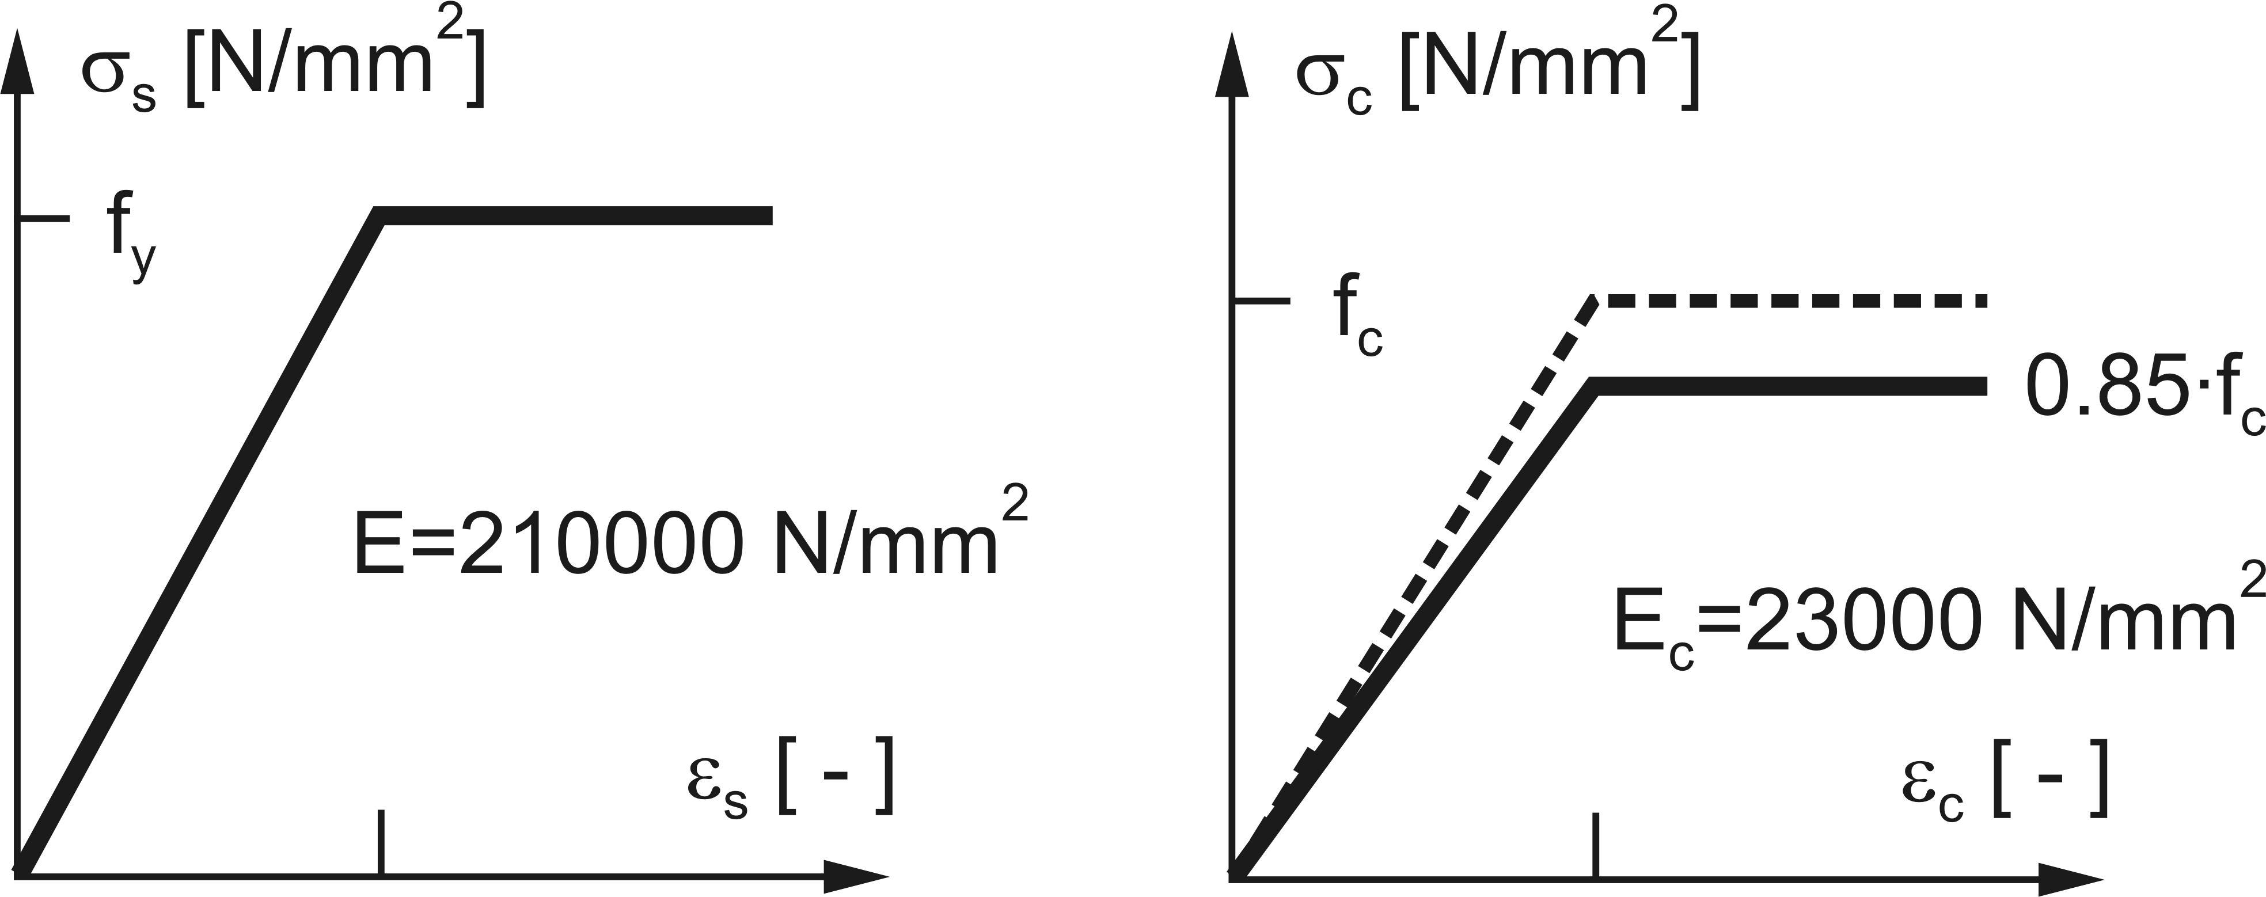
Fig. 1 Drawing
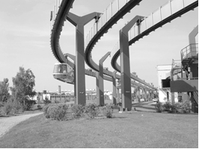
Fig. 2 Greyscale photograph
All figures should be numbered consecutively and captioned; the caption should be 11pt Times New Roman font, upper and lower case letters. A 6pt space should separate the figure from the caption, and 12pt spaces should separate the upper part of the figure and the bottom of the caption from the surrounding text.

4 conclusions
Papers should be provided with a section giving the main conclusions of the work presented, which should be clear and concise.
- Papers must be submitted as both a PDF version in High Quality Print and as a Word file (2003 or later versions), before 31 May 2015 using the submission system provided on the web site of the ASFE’15 Conference (http://www.grad.unizg.hr/asfe2015/papers).
- The files should be named as follows: Paper ID_Last name of the first author.doc (e.g. 032_Horova.doc). The Paper ID was provided on the confirmation e-mail from asfe@grad.hr on acceptance of the abstract.
- The organizers can not commit themselves to include in the Proceedings any paper received later than above-mentioned deadline. At least one of the authors must register and pay his/her registration fee in order for their paper to be included in the final programme of the Conference. Each registration allows the presentation of two papers.

Acknowledgments
This optional heading should be inserted just before Reference heading. Both headings (ACKNOWLEDGEMENTS and REFERENCES) should be in bold Times New Roman font 12pt, without numbering. Acknowledgments text should be in Times New Roman font 11pt.

References
The Harvard (surname(s) and year) short reference system (e.g. Wang et al., 2012) should be used for citations in the text, with a detailed alphabetical-order list at the end of the paper. References should be single-spaced, using Times New Roman font 11pt in a single column. The list of references should be formatted as given below. Please ensure that every reference cited in the text is also present in the reference list and vice versa. Commercial papers or documents not available to the public should not be referenced.
Annerel E., Taerwe, L., Vandevelde P., 2007. Assessment of temperature increase and residual strength of SCC after fire exposure, in 5th International RILEM Symposium on Self-Compacting Concrete, 3-5 September 2007, Ghent, Belgium, p. 715-720.
(Conference proceedings: surname(s), first name initial(s), year, title of the article, title of the conference, date (day and month) and place (city and country) of the conference, page numbers)
Gaweska-Hager I., 2004. Behaviour at High Temperature of High-Performance Concrete: Evolution of the Main Mechanical Properties, PhD Thesis, Ecole Nationale des Ponts et Chaussees (in French).
(thesis or dissertation: surname, first name initial(s), year, title of the thesis, university)
Khaliq W., Kodur V. 2011. Thermal and mechanical properties of fiber reinforced high performance self-consolidating concrete at elevated temperatures. Cement and Concrete Research, 41(11), p. 1112–1122.
(journal paper: surname(s), first name initial(s), year, title of the article, title of the journal, volume, issue, page numbers)
Wang Y.C., Burgess I.W., Wald F., Gillie, M. 2012. Performance-Based Fire Engineering of Structures, Boca Raton, Florida, USA: CRC Press.
(book: surnames, first name initials, year, title of the book, publisher)
Please proof-read your paper. Thanks.

